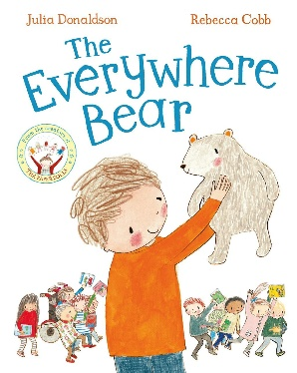
My Top 5 book Recommendations

The Everywhere Bear by Julia Donaldson
A lovely story about school, friendship and belonging that is perfect for the start of the year.
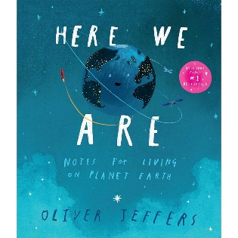

Here We Are by Oliver Jeffers
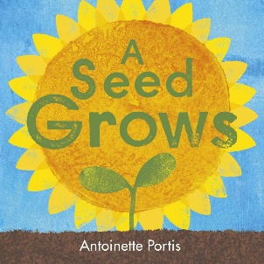
Explores our world, kindness and looking after our planet—ideal for RE and Geography.

A Seed Grows by Antoinette Portis
A beautiful introduction to living things, life cycles and nature.

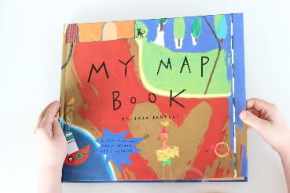

My Map Book by Sara Fanelli
Inspires children to create imaginative maps and supports your mapping unit brilliantly.
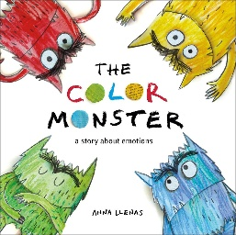

The Colour Monster by Anna Llenas
Helps children recognise and talk about emotions,

